Spieleentwicklung für Mobile Geräte

Spiele Idee
- 2D
- Top Down.
- Harvest in a Fight to get Items like Pots.
- Fight Against Enemys to Collect new Items.
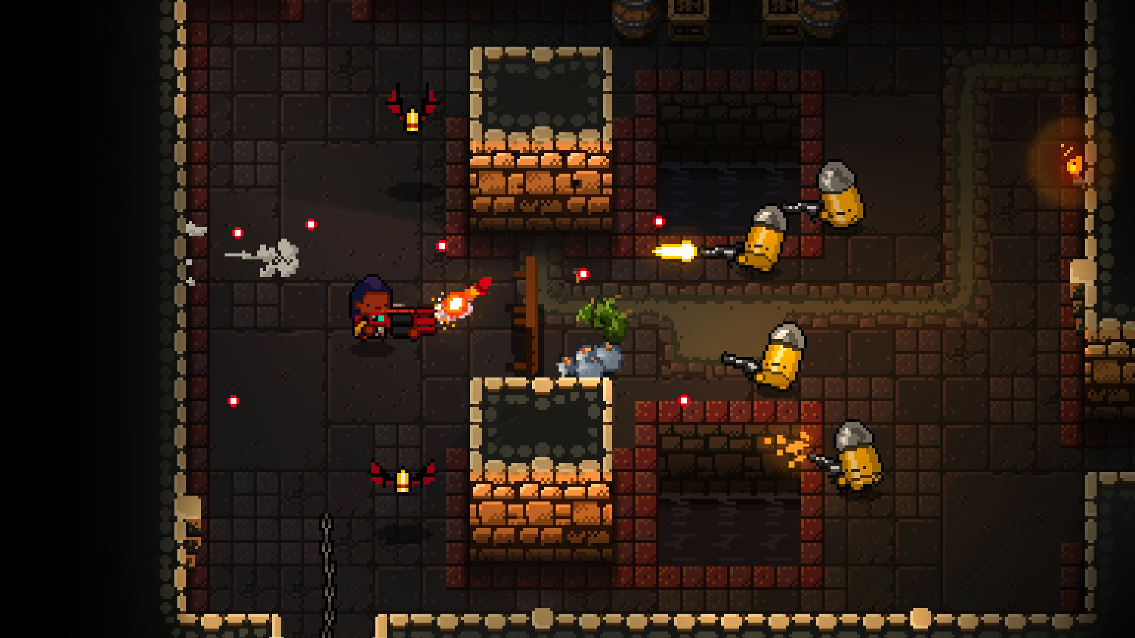
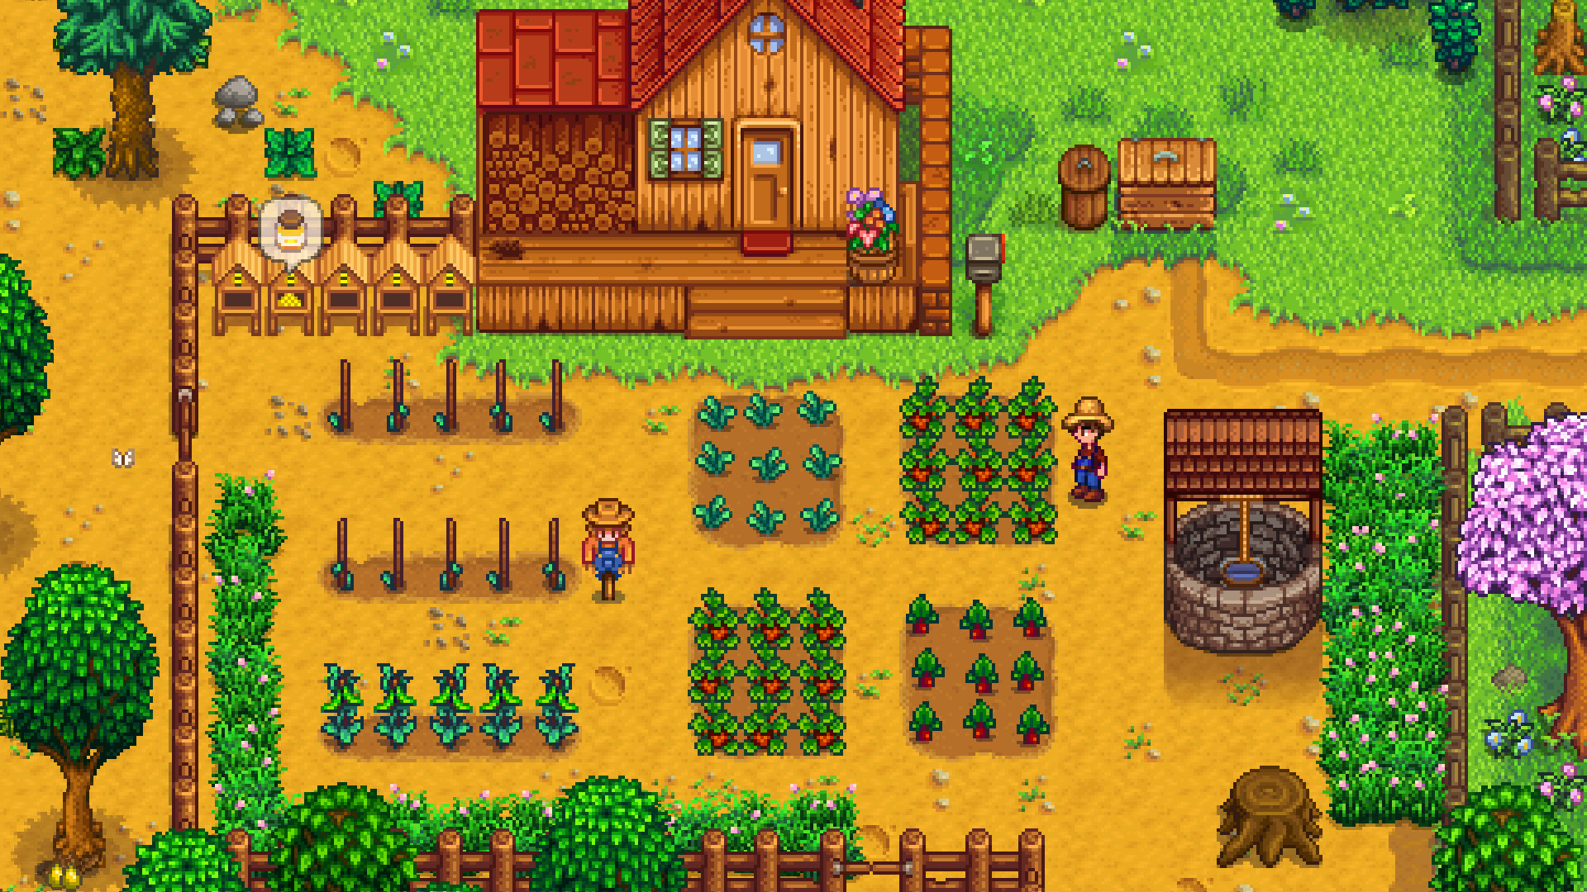

Was wird benötigt zu Implementieren?
- Timer
- Very Simple Enemy AI
- One Weapon and 1 – 2 Harvesting Object
- Some Items
- Spawn System of Items and Enemys
- Highscore System
- Delivery Event

User Inputs
- WASD or Joystick
- 1-2 Action Butten / Mouse

